Direction générale de la Santé
Paris, 13th septembre 2019
Press Release
World sepsis day
Delivery of the report "Sepsis - all united against a little-known scourge": 10 measures to improve the management in France of the most serious form of infections

In a mission letter dated May 7th 2018, Professor Jérôme Salomon, Director-General of Health, instructed Professor Djillali Annane to make recommendations to improve the prevention, diagnosis and management of sepsis in France.
Professor Annane, recognized as one of the world's leading experts in sepsis, has worked with all the learned societies involved. Among the 10 recommendations formulated, priority is given to raise awareness among the public and health professionals to detect signs of sepsis as early as possible and to implement a specific sepsis care pathway, adapted to all ages of life.
The World Health Organization (WHO) estimates that nearly 30 million people suffer from sepsis each year, and nearly 6 million people die of it. At its 70th World Assembly on 29th May 2017, WHO called on all states to respond to sepsis by taking action in the areas of education, information, prevention, diagnosis, care and research. In France, according to the Resuscitation Society of French-Language (Société de Réanimation de Langue Française), at least 180,000 people, at all ages of life, are victims of sepsis each year.

Sepsis is almost completely unknown to the public and still poorly understood by health professionals. Sepsis is defined as an acute state of dysregulation of the body's response to an infection (bacterial, viral, fungal or parasitic) resulting in loss of organ function and a life-threatening risk to the patient. When this acute condition is characterized by circulatory failure and major cellular suffering, the term septic shock is used.

In this context, the report submitted by Professor Annane recommends implementing 10 measures to better know, care for and monitor sepsis better.
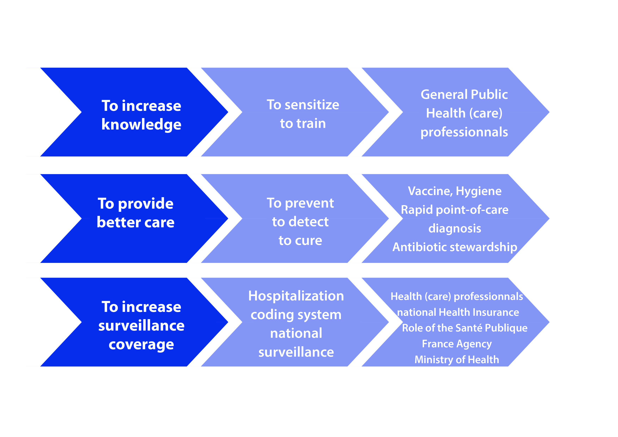

Click here for access the report

Sepsis is the most serious complication of infections
It can occur unpredictably, during any infection, usually bacterial, but also viral, including influenza infection (flu).
Sepsis occurs because the body's defenses against infection are disrupted, most often resulting in excess inflammation, which in turn prevents the various organs from functioning.
Sepsis should be suspected as soon as:
- An infection is present
- Breathing accelerates: more than 22 cycles per minute
- Blood pressure is low: systolic (maxima) < 10
- Consciousness is altered: incoherent words, loss of sense of orientation in time or space, hallucinations, loss of recognition of loved ones, drowsiness or, on the contrary, agitation.

Media contact : presse-dgs@sante.gouv.fr Tel: + 33 1 40 56 84 00

